HEALTH CARE CHATBOT USING ML IN PYTHON
A
MAJOR PROJECT-II REPORT
Submitted in partial fulfillment of the requirements for the degree of

BACHELOR OF TECHNOLOGY
in

COMPUTER SCIENCE & ENGINEERING

By

GROUP NO. 15

Satya Ranjan Majhi 0187CS211149 Utsav Raj 0187CS211177
Vishakha Sharma 0187CS211182
Zeeshan Alam 0187CS211189

Under the guidance of Prof. Mayank Kurchaniya (Assistant Professor)


Department of Computer Science & Engineering
Sagar Institute of Science &Technology (SISTec), Bhopal (M.P)
Approved by AICTE, New Delhi & Govt. of M.P.
Affiliated to Rajiv Gandhi Proudyogiki Vishwavidyalaya, Bhopal (M.P.)

June -2025


Sagar Institute of Science & Technology (SISTec), Bhopal (M.P.) Department of Computer Science & Engineering
CERTIFICATE

We hereby certify that the work which is being presented in the B.Tech. Major Project-I Report entitled Healthcare chatbot using ML in python, in partial fulfillment of the requirements for the award of the degree of Bachelor of Technology, submitted to the Department of Computer Science & Engineering, Sagar Institute of Science & Technology (SISTec), Bhopal (M.P.) is an authentic record of our own work carried out during the period from Jan-2025 to Jun-2025 under the supervision of Prof. Mayank Kurchaniya.

The content presented in this project has not been submitted by me for the award of any other degree elsewhere.

Satya Ranjan Majhi | Utsav Raj | Vishakha Sharma | Zeeshan Alam
0187CS211149 | 0187CS211177 | 0187CS211182 | 0187CS211189

This is to certify that the above statement made by the candidate is correct to the best of my knowledge.
Date:

Prof. Mayank Kurchaniya | Dr. Amit Kumar Mishra | Dr. D.K. Rajoriya
Project Guide | HOD, CSE | Principal

We would like to express our sincere thanks to Dr. D. K. Rajoriya, Principal, SISTec and Dr. Swati Saxena, Vice Principal SISTec Gandhi Nagar, Bhopal for giving us an opportunity to undertake this project.

We also take this opportunity to express a deep sense of gratitude to Dr. Amit Kumar Mishra, HOD, Department of Computer Science & Engineering for his kindhearted support

We extend our sincere and heartfelt thanks to our guide, Prof. Mayank Kurchaniya, for providing us with the right guidance and advice at crucial junctures and for showing us the right way.

I am thankful to the Project Coordinator, Prof. Deepti Jain, who devoted her precious time in giving us the information about various aspects and gave support and guidance at every point of time.

I would like to thank all those people who helped me directly or indirectly to complete my project whenever I found myself in any issue.

TITLE | PAGE NO.
Abstract | i
List of Abbreviation | ii
List of Figures | iii
Chapter-1: Introduction | 1
1.1 About Project | 1
1.2 Project Objective | 2
1.3 Functionality | 3
1.4 Interface | 4
1.5 Design and Implementation Constraints | 5
1.6 Assumption and Dependencies | 7
Chapter-2: Software and Hardware Requirements | 9
2.1 Introduction | 9
2.2 Software Requirement | 9
2.3 Hardware Requirement | 10
Chapter-3: Problem Description | 12
3.1 Overview | 12
3.2 Problems in the Existing System | 12
3.3 Project Impact and Significance | 13
3.4 Conclusion | 14
Chapter-4: Literature Survey | 15
4.1 Literature Survey | 15
Chapter-5: Software Requirements Specification | 19
5.1 Functional Requirements | 19
5.2 Non-Functional Requirements | 20
Chapter-6: Software Design | 23
6.1 Use Case Diagram | 23
6.2 ER Diagram | 24
6.3 Data Flow Diagram | 25
6.4 Conclusion | 25
Chapter-7: Output Screens | 26
7.1 Output Screens | 27
Chapter-8: Deployment | 29
8.1 Overview | 30

Deployment Architecture 30
  - Deployment of Frontend 31
  - Deployment of Backend 31
  - Database Setup 31
  - Model Development (NLP+ML) 32
  - Continuous Deployment 32
  - Conclusion 32
  - Reference Project Summary
Appendix-1: Glossary of Terms

ABSTRACT

Healthcare Bot is an intelligent web-based system designed to assist users in identifying possible health issues through natural language conversation. Developed using Python, the system leverages Natural Language Processing (NLP) and machine learning techniques to simulate human-like interactions and provide relevant medical suggestions based on user symptoms. It aims to reduce the burden on healthcare systems by offering a preliminary analysis before medical consultation, especially in remote areas where professional help may not be instantly available.
The core technology stack includes Python along with libraries like NumPy, Pandas, Scikit-learn, and TensorFlow/Kera’s for machine learning, including deep learning models like LSTM and Transformers for intent recognition and symptom classification. Streamlit is used to build a simple yet effective frontend interface, enabling users to interact with the chatbot in real time. The system is trained on a dataset of symptoms and diseases and can suggest probable conditions based on user inputs. It also uses the TF-IDF vectorizer and Logistic Regression for text classification tasks.
One of the unique challenges in developing Healthcare Bot was ensuring accurate intent recognition and symptom matching using limited and often unstructured user input. This was addressed using advanced NLP techniques such as lemmatization, stop word removal, and tokenization. The chatbot can handle vague symptom descriptions and respond with clarity, asking follow-up questions if needed. It is also capable of identifying emergencies and recommending immediate medical attention.
Security, accuracy, and scalability were core priorities during development. User inputs are sanitized to prevent injection attacks, and the model is continuously trained to adapt to new data for better prediction accuracy. The modular design of the system ensures that updates can be made independently to components like the model, interface, or dataset. Its scalable backend ensures smooth performance even with increased user load.
Healthcare Bot aims to revolutionize the way users access preliminary medical information. With its interactive design, intelligent response system, and secure, scalable architecture, it serves as a reliable digital companion for users seeking quick health insights. By combining machine learning with user- centric design, it offers a practical and innovative approach to modern healthcare support.

LIST OF ABBREVIATIONS

ACRONYM | FULL FORM
API | Application Programming Interface
CRUD | Create, Read, Update, Delete
DBMS | Database Management System
ERD | Entity-Relationship Diagram
GUI | Graphical User Interface
HTML | Hyper Text Markup Language
HTTP | Hyper Text Transfer Protocol
HTTPS | Hyper Text Transfer Protocol Secure
IDE | Integrated Development Environment
JSON | JavaScript Object Notation
JWT | JSON Web Token
MVC | Model-View-Controller
NoSQL | Not Only Structured Query Language
ODM | Object Data Modeling
OOP | Object-Oriented Programming
RAM | Random Access Memory
RBAC | Role-Based Access Control
REST | Representational State Transfer
SaaS | Software as a Service
SQL | Structured Query Language
SSL | Secure Sockets Layer
UI | User Interface
UX | User Experience
VM | Virtual Machine
VS Code | Visual Studio Code

LIST OF FIGURES

FIG. NO. | TITLE | PAGE NO.
6.1.1 | Use Case Diagram | 23
6.2.1 | ER Diagram | 24
6.3.1 | Level 0 Data Flow Diagram | 25
7.1.1 | Home Page | 26
7.1.2 | About Us Page | 26
7.1.3 | Conversation With User | 27
7.1.4 | Output Screen | 27
7.1.5 | Output Screen no.2 | 28
7.1.6 | Output Screen no.3 | 28

CHAPTER 1 INTRODUCTION

ABOUT PROJECT

Healthcare Bot is an AI-powered healthcare chatbot designed to assist users with health- related queries by simulating intelligent conversations through Natural Language Processing (NLP) and Machine Learning (ML). This virtual assistant enables users to describe symptoms in natural language and receive preliminary health insights instantly, reducing dependency on physical consultations for non-critical concerns.
Developed using Python, the system integrates deep learning models such as LSTM and Transformers for intent recognition and symptom analysis. Healthcare Bot provides an interactive web interface built with Flask, enabling seamless communication between users and the backend ML engine. The chatbot analyzes user inputs using trained models on healthcare datasets and delivers accurate, real-time responses based on identified intents and symptoms.
Healthcare Bot addresses the limitations of traditional rule-based chatbots by leveraging deep learning for contextual understanding, making interactions more dynamic and informative. The system is capable of understanding diverse user inputs, offering health advice, and promoting proactive wellness habits. Additionally, the platform ensures secure handling of user data through proper encryption and ethical AI practices.

By combining conversational AI with healthcare knowledge, Healthcare Bot offers an accessible, always- available assistant aimed at improving healthcare outreach and reducing the burden on medical professionals. It delivers a reliable, cost-effective alternative for health assistance,

particularly in areas with limited access to healthcare infrastructure, making healthcare more inclusive and responsive to individual needs.

PROJECT OBJECTIVES

The primary objective of Healthcare Bot is to develop a smart, interactive chatbot that enhances healthcare accessibility by using machine learning and NLP to deliver timely health assistance. The key goals of the project include:

- Enable Accessible Health Support: Provide users with quick, reliable responses to common health concerns, anytime and from anywhere.
- Utilize Deep Learning Models: Implement LSTM and Transformer-based models for accurate intent recognition and symptom classification.
- Natural Language Understanding: Process user inputs in conversational language, extracting health-related data with high precision.
- Interactive Web-Based Interface: Develop a user-friendly frontend using Flask for real-time communication with the chatbot.
- Integrate NLP Pipeline: Use tokenization, lemmatization, and semantic parsing for effective language processing.
- Scalable & Modular Architecture: Build a robust backend in Python with modular components for easy expansion and maintenance.
- Improve User Engagement: Deliver human-like interactions with context- aware responses to enhance user satisfaction and trust.
- Ensure Security & Data Privacy: Implement secure protocols for data handling, ensuring user privacy and ethical compliance.
- Low-Cost & Efficient Operation: Use open-source tools and pre-trained models to keep development and deployment cost-effective.
- Contribute to Preventive Care: Promote health awareness and self-care by offering early guidance before medical consultation.

FUNCTIONALITY

Healthcare Bot offers a set of intelligent and user-focused functionalities designed to deliver a responsive and informative virtual healthcare assistant experience. The system supports efficient interactions between users and the AI engine, tailored for symptom assessment, health guidance, and secure data management. The key features and functionalities of the chatbot platform are as follows:

User Functionality

Symptom Input & Query: Users can enter symptoms in natural language to receive immediate AI- driven responses.
Preliminary Health Suggestions: Based on the symptoms, the bot provides possible causes and health tips.
Interactive Chat Interface: Users engage with the chatbot through a clean and responsive web-based interface.
Conversation History: View previous chats and recommendations for follow-up or monitoring.
User Dashboard: Manage personal details, symptom history, and access chatbot features easily.

Backend Functionality

Intent Detection: Identify user intent using NLP models trained on healthcare conversations.
Symptom Analysis: Classify and analyze symptoms using LSTM and Transformer models.
ML Model Integration: Leverage machine learning pipelines for real- time query classification and response.
Dataset Handling: Use healthcare datasets for model training and testing, ensuring relevant predictions.

Admin Functionality

Manage User Queries: Monitor chatbot interactions and review critical or flagged conversations.
Model Update & Training: Upload new training data and retrain ML models as needed.

Monitor Performance: Track system performance, chatbot accuracy, and usage logs. Data Control & Logs: Access logs of interactions, system errors, and maintain compliance.

Platform-wide Functionalities

Authentication & User Privacy: Secure login and encrypted communication for all users. Modular ML Design: Easily update or replace ML models without affecting core functionality. Responsive UI: Optimized for all devices to ensure consistent user experience. Searchable Symptom Library: Help users find symptoms or health topics with a built- in search function.

INTERFACE

Healthcare Bot is built with an intuitive, responsive, and user-centric interface to ensure effective interaction between users and the AI-powered chatbot. The interface is developed using Python (Flask/Streamlit/React if applicable), ensuring seamless communication, real- time response, and device compatibility. The platform includes role-based access for users and administrators, tailored to their respective functionalities.

User Interface

Home Page: Introduces the chatbot, its features, and provides an input area for users to start their health queries.
Chat Window: Interactive chat interface where users can type symptoms in natural language and receive instant responses.
Health History: Displays past symptom queries, chatbot responses, and health suggestions. Symptom Suggestion Panel: Shows common symptoms and health concerns to assist users in framing their inputs.
Response Display Area: Presents possible causes, recommended next steps, and guidance based on symptoms.
User Dashboard: Centralized view for managing user details, chat history, and accessing saved health information.

Admin Interface

User Monitoring Panel: Allows administrators to view user interaction data and flagged conversations.
Chat Log Access: View and audit historical conversations for quality assurance and data analysis. Model Management: Interface to upload new training data, retrain models, and manage version control.
System Dashboard: Monitor system health, performance metrics, and manage logs or exceptions.

DESIGN AND IMPLEMENTATION CONSTRAINTS

Healthcare Bot is designed to deliver accurate health responses using machine learning and NLP. However, several constraints affect its architecture, implementation, and performance. These constraints are categorized below:

Hardware Constraints

Server Requirements: The system requires a machine with a minimum of 4GB RAM, dual-core CPU, and adequate storage to process ML models and user queries.
Hosting Infrastructure: Deployment on cloud platforms (such as Heroku, Render, or AWS) is essential to ensure 24/7 availability.

Client-side Requirements: Users must have access to a device with internet and a web browser or app to interact with the chatbot interface.

Software Constraints

Technology Stack: Developed using Python with Flask or Streamlit for the frontend, restricting integration with other backend stacks.
ML Libraries: The project uses Scikit-learn, Pandas, NumPy, and TensorFlow, which require compatible versions and dependencies.
Database Management: Utilizes SQLite or MongoDB for lightweight data storage, which may not support high-concurrency scenarios.
External APIs: Symptom datasets and health prediction modules depend on external libraries or pre-trained models.

Functional Constraints

Role-Based Access: Only users and admins exist, limiting feature access and ensuring data confidentiality.
Limited Diagnosis Scope: The chatbot provides preliminary health suggestions and not professional medical diagnosis.
Query Restrictions: Only symptom-based inputs in simple natural language are supported; complex queries may not yield accurate results.

Performance Constraints

Model Load Time: Deep learning models (LSTM/Transformer) may introduce slight delays in generating responses on low-spec servers.
Concurrent Requests: The application must handle multiple users querying simultaneously, which may affect performance under heavy load.
Latency in Predictions: Health prediction responses may take time based on model complexity and available processing power.

Security Constraints

Authentication System: JWT-based user login must be implemented to secure access and track user activity.
Data Privacy: All personal and symptom data must be encrypted using HTTPS and stored securely.
Access Control: Admin functionality and logs should be protected from unauthorized access through strict role-based authentication.

ASSUMPTIONS AND DEPENDENCIES

The development and functionality of Healthcare Bot rely on a set of assumptions and external dependencies that influence its usability, accuracy, and overall system performance.

Assumptions

Users Have Internet Access: The chatbot is hosted online and requires a stable internet connection for real- time interaction and health query processing.
Users Provide Valid Symptoms: It is assumed that users will input actual symptoms in proper format to receive accurate responses.
Basic Tech Familiarity: Users are expected to have basic knowledge of operating chat interfaces and navigating the web interface.
Health Queries Are for Suggestion Only: The system assumes that users understand that the chatbot offers guidance and not professional medical advice.
Data Input is Honest: The chatbot’s accuracy depends on users entering genuine and complete health-related information.
Admin Monitors System Logs: It is assumed that the admin will regularly manage system logs and usage statistics to maintain data quality and security.

Dependencies

Python & ML Libraries: The system relies on Python with dependencies on libraries such as Pandas, NumPy, Scikit-learn, and TensorFlow for NLP and model training.
NLP Models: Intent recognition and symptom analysis depend on pre- trained LSTM or Transformer models. Changes in these models or training data may affect results.
Framework (Flask/Streamlit): The chatbot runs on a lightweight Python-based web framework. Any update in framework APIs may require code changes.
External Datasets: The accuracy of predictions depends on the quality and coverage of public or custom- trained healthcare datasets used during model training.
Hosting Server: The system relies on cloud deployment (Heroku, Render, etc.) to ensure constant uptime and responsiveness.
Browser Support: The application assumes users access the chatbot using a modern browser. Incompatible browsers may limit functionality.
Security Modules: Authentication relies on JWT or similar token- based systems. Updates in these modules can affect access and security mechanisms.

CHAPTER 2 SOFTWARE & HARDWARE REQUIREMENTS

INTRODUCTION

For the successful development, deployment, and smooth functioning of the Health Care Chat Bot using ML in Python, specific software and hardware components are essential. On the software side, this includes machine learning libraries, NLP toolkits, backend frameworks, and cloud APIs for data handling and model deployment. The use of robust development environments and testing tools ensures the accuracy, reliability, and scalability of the chatbot system.
From a hardware perspective, development systems should have sufficient processing power and memory to support ML model training, while deployment servers must handle multiple user interactions simultaneously. Additionally, end-users require internet-enabled devices with a browser or chat interface to interact with the system. This chapter outlines the complete list of required software and hardware components for efficient operation and development of the chatbot platform.

SOFTWARE REQUIREMENTS

Development Tools & Technologies

Programming Language: Python 3.10+ (For ML model training and chatbot logic)
Framework: Flask (For API and web interface integration)
Machine Learning Libraries: Scikit-learn, Pandas, NumPy, TensorFlow / PyTorch (for model training) NLP Libraries: NLTK, SpaCy, Transformers (for intent recognition and symptom analysis)
Database: SQLite / MongoDB (for storing user queries, symptoms, and chat logs)
Operating System: Windows 10/11, Ubuntu 20.04+, macOS (Development Environment)

Testing Tools

Postman: For API endpoint testing.

PyTest / Unit test: For testing Python modules.
Jupyter Notebook: For interactive model validation and performance analysis.

Deployment & Hosting Services

Web/App Hosting: Render / PythonAnywhere / Heroku.

Model Hosting: Hugging Face / Firebase (for deploying NLP models).

Version Control: Git & GitHub for source code management and collaboration.

Domain & Access: Custom domain via Namecheap or similar (if web portal is used).

HARDWARE REQUIREMENTS

    - Developer System Requirements Processor: Intel i5 or AMD Ryzen 5 (or higher)
RAM: Minimum 8GB (Recommended: 16GB for ML model training)

Storage: 256GB SSD (Recommended: 512GB SSD for handling datasets and models)

Graphics: Dedicated GPU (Optional, for faster training using TensorFlow or PyTorch).
Operating System: Windows 10/11, Ubuntu, or macOS.

Internet Connection: Stable broadband for accessing libraries, APIs, and cloud storage.

    - Server Requirements (Hosting) Processor: Quad-core or higher
RAM: Minimum 8GB RAM (Recommended: 16GB for handling multiple users and API requests)
Storage: Minimum 100GB SSD (Expandable for logs, chat history, and models)

Bandwidth: High-speed connection with at least 10 Mbps upload/download speed

End-User Requirements

Device: Smartphone, Laptop, or Desktop

RAM: Minimum 2GB (Recommended: 4GB+ for smoother interaction) Browser/Interface: Chrome, Firefox, Safari, or mobile app with chat interface Internet Speed: Minimum 2 Mbps (Recommended: 5 Mbps for real-time response)

CHAPTER 3

PROBLEM DESCRIPTION

OVERVIEW
With the growing need for accessible and efficient healthcare services, traditional medical consultation methods face several challenges. Long waiting times, geographical limitations, high consultation costs, and a lack of immediate assistance are some of the issues patients often encounter. Additionally, individuals with non-critical symptoms may avoid medical consultations due to inconvenience, leading to delayed treatments.
The Health Care Chatbot using ML in Python is designed to address these issues by offering an intelligent, user- friendly, and accessible platform where users can get instant health- related support. By leveraging Natural Language Processing (NLP) and machine learning, the system interacts with users, analyzes their symptoms, and provides suggestions or guidance based on trained data models.

PROBLEMS IN THE EXISTING SYSTEM

Limited Accessibility to Healthcare Services

Many individuals in remote or underdeveloped areas lack access to immediate medical consultations. Traditional appointments require physical visits, which may not be feasible in emergencies or for minor issues.

High Consultation Costs

In-person medical consultations can be expensive for non-serious conditions. Existing platforms may require subscriptions or fees for basic symptom checks.

Delayed Medical Attention

Patients often delay seeking help due to unavailability of doctors or time constraints. Lack of preliminary diagnosis may worsen the condition before proper consultation occurs.

Lack of Intelligent Interaction

Existing chatbots may rely on static responses and fail to understand complex user queries.

Most systems do not incorporate deep learning for accurate symptom analysis and intent detection.

Inconsistent Health Information

Users often rely on unreliable sources for self-diagnosis. Misinformation can lead to incorrect self-treatment or panic.

No Personalized Experience

Current tools don’t adapt based on user history, age, or prior conditions. Absence of contextual awareness reduces chatbot effectiveness.

PROJECT IMPACT AND SIGNIFICANCE

The Health Care Chatbot tackles these problems by providing a real-time, intelligent, and accessible health assistant with key features such as:
Instant Symptom Analysis: Users can interact with the chatbot anytime, anywhere, to describe their symptoms in natural language.
ML-Powered Intelligence: NLP models like LSTMs and Transformers help identify user intent and symptoms accurately.
Cost-Free Basic Consultation: The chatbot provides general health advice, reducing the need for unnecessary doctor visits.
User-Centric Design: The platform ensures ease of use with a friendly conversational interface built in Python. Data-Driven Suggestions: Based on trained health datasets, the chatbot recommends actions like hydration, rest, or professional consultation.

Secure & Private Interaction: User data is handled confidentially, ensuring privacy in all communications.

CONCLUSION

Traditional healthcare systems face several limitations including inaccessibility, high consultation costs, and time-consuming procedures, particularly for minor health concerns. Many people either avoid medical help or turn to unverified sources due to these barriers.
The Health Care Chatbot using ML in Python is built to fill this gap by offering an AI- powered, secure, and easy-to-use health assistant. With NLP and deep learning techniques like LSTM and Transformers, the chatbot provides quick and relevant health advice, symptom analysis, and decision support to users in need.
Designed for scalability and accessibility, the chatbot supports users from all regions and backgrounds by providing a cost-effective solution for general health queries. As the demand for digital healthcare continues to rise, this project has the potential to transform preliminary health screening and education, making essential services more available, efficient, and personalized.

CHAPTER 4
LITERATURE SURVEY

LITERATURE SURVEY
The integration of Machine Learning (ML) and Natural Language Processing (NLP) into healthcare systems has revolutionized patient interaction by enabling AI-driven chatbots for primary diagnosis, information dissemination, and appointment scheduling. This section surveys existing research, tools, and technologies employed in healthcare chatbots, identifying their merits and shortcomings to highlight how our system advances the domain.

Evolution of Healthcare Chatbots

Early healthcare chatbots were rule-based systems operating on predefined scripts. Tools like ELIZA and early medical expert systems provided limited interactivity, lacking contextual understanding. Recent advancements in deep learning and NLP have given rise to intelligent chatbots capable of understanding symptoms, predicting illnesses, and providing recommendations based on user inputs.
Platforms such as Ada Health and Babylon use AI to perform symptom assessments and triage. While effective, these systems are often closed- source, require heavy infrastructure, and lack customization for local or institutional deployment. Our system aims to address these limitations by offering a lightweight, Python-based chatbot leveraging LSTM and Transformer architectures for improved intent recognition and symptom analysis.

Role of Technology in AI-Powered Health Chatbots

Modern healthcare chatbots utilize various AI and software technologies to deliver real-time, secure, and interactive experiences:

Python and ML Libraries for Development

Python offers rich libraries for ML and NLP such as TensorFlow, Scikit-learn, Numpy, and Pandas.

Our system uses these libraries to train intent recognition models and analyze symptoms using a deep learning backend.

NLP for Medical Query Understanding

Chatbots require strong NLP models to interpret user intent and extract entities like symptoms or duration.
Our system integrates tokenization, lemmatization, and named entity recognition techniques to ensure accurate understanding.

Symptom Analysis with Deep Learning

Using LSTM and Transformer-based models improves context retention and understanding of complex sentences.
The chatbot can predict probable conditions based on symptom sets, improving patient guidance.

Web Deployment and APIs

Technologies like Flask and Fast API are used to expose the ML model through APIs for web integration. The system supports easy embedding into web-based hospital portals or standalone applications.
    - Comparison with Existing Solutions

Feature | Ada Health | Babylon Health | Our System
Open Source | + | + | ■
Customizable NLP Engine | + | + | ■

Feature | Ada Health | Babylon Health | Our System
Deep Learning-  Based Symptom Check | ■ | ■ | ■  (LSTM & Transformer)
Lightweight  Python Deployment | + | + | ■
Institution-Level Integration | + | + | ■

    - Challenges in Healthcare Chatbots

- Medical Accuracy & Safety

AI systems can misdiagnose or suggest incorrect advice if not trained properly.
Solution: Our model is trained on validated datasets and undergoes manual testing to ensure safety.

Language Understanding

Slang, grammatical errors, or regional languages often confuse traditional bots.

Solution: The chatbot applies pre-processing techniques and contextual embedding models (like BERT) for robust interpretation.

Data Privacy and Security
Patient data handling requires strict adherence to data protection standards.

Solution: We use HTTPS, JWT-based authentication, and anonymization to protect user data.

Scalability and Integration

Many models fail to perform efficiently under high user loads or lack flexible APIs.
Solution: Our backend supports asynchronous API calls and modular design for scalability.

Future of AI in Healthcare Chatbots

The future of medical AI chatbots includes:
Real-time integration with Electronic Health Records (EHR) systems. Support for voice-based assistants and multilingual support.
Predictive healthcare analytics and emergency triage features.

Conclusion

AI-driven healthcare chatbots have emerged as critical tools in modern telemedicine. While platforms like Ada and Babylon demonstrate the potential of such systems, they often lack transparency, scalability, and openness. Our proposed system leverages Python, ML, and deep NLP to create a secure, accurate, and customizable healthcare chatbot suitable for educational institutions and clinics. With enhanced symptom understanding, real-time deployment, and robust data handling, this chatbot aims to bridge the accessibility gap in preliminary medical consultation.

CHAPTER 5

SOFTWARE REQUIREMENT SPECIFICATION

FUNCTIONAL REQUIREMENTS

User Roles and Functionalities

- Admin

Manage user records (patients and doctors). View system usage analytics.
Oversee chatbot performance and training logs. Handle data compliance and privacy protocols.

Doctor

Login securely via email-based authentication.

Access patient queries and chatbot-predicted symptom data.

Review chatbot diagnosis and provide feedback for learning improvement.

Update health tips, FAQs, and validated medical information in the knowledge base.

Patient/User

Register/Login using email or social authentication.
Interact with the chatbot to describe symptoms in natural language. Receive initial symptom analysis and potential diagnosis.
View health tips and recommended actions.

Option to consult a doctor based on chatbot suggestions.

Chatbot Functionalities

Real-time chat interface powered by NLP and deep learning. Intent detection using trained LSTM/Transformer models.
Entity extraction for symptoms, duration, severity, etc. Prediction of probable illness based on input.

Fallback mechanism for unrecognized queries.

Doctor-Patient Communication
Secure channel for doctors to message patients.

Doctors receive chatbot session summary before consultation.

Patients can book appointments or schedule calls via the platform.

Machine Learning & NLP Integration
Intent recognition for categorizing user input.

Symptom extraction using NER (Named Entity Recognition). Model trained using real-world symptom datasets.
Continuous learning with admin-verified corrections.

Authentication & Security

JWT-based secure login for users and doctors. Role-based access controls for different user levels. End-to-end encryption for chat and personal medical data. Passwords hashed using bcrypt algorithm.

NON-FUNCTIONAL REQUIREMENTS

Performance Requirements

Chatbot should respond within 1 second for 90% of queries. Concurrent handling of up to 300 active users. ML inference latency not exceeding 2 seconds per query.

Security Requirements

All user interactions secured over HTTPS. Sensitive health data encrypted at rest and in transit. Follows healthcare-grade security practices and token-based sessions.

Usability Requirements

Clean and intuitive chatbot UI with mobile responsiveness. Step-by-step query flow for better user guidance. Dark and light theme toggle for accessibility.

Scalability Requirements

Scalable backend using Python FastAPI and containerization (Docker). Deployed on cloud infrastructure (e.g., Heroku or AWS EC2).
MongoDB can handle expanding user-base and chat logs efficiently.

Availability & Reliability

Target 99.9% system uptime.

Load balancing to ensure availability during high traffic. Auto-restart and recovery of chatbot service in case of crash.

Maintainability & Extensibility

Code follows modular and MVC-based structure.

Separation of training pipeline and runtime inference for clarity. Easy integration of advanced models (e.g., BERT, GPT) in future.

Compliance Requirements

Compliant with GDPR for user data handling. Anonymization of stored health data to maintain privacy. Medical content aligned with standard disclaimers and legal policies.

CHAPTER 6

SOFTWARE DESIGN

USE CASE DIAGRAM
The Use Case Diagram represents user interactions with the Healthcare Chatbot system.

Actors in the System:
- User (Patient)

Ask health-related queries. Receive chatbot responses. View past interactions.

Healthcare Chatbot (Healthcare Bot)

Classify user intent.

Identify patterns in user input.

Search for matching responses in the database. Generate responses based on previous data. Store new queries for learning and future improvements.

Use Case Diagram for Healthcare chatbot:

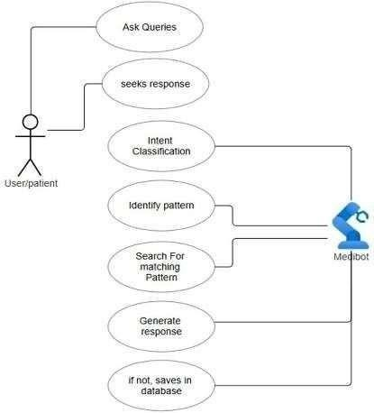

Figure 6.1.1: Use Case Diagram

ER DIAGRAM
Since MongoDB is a NoSQL database, it follows a document-oriented model, where data is stored in collections instead of relational tables.

Key Collections in the System:

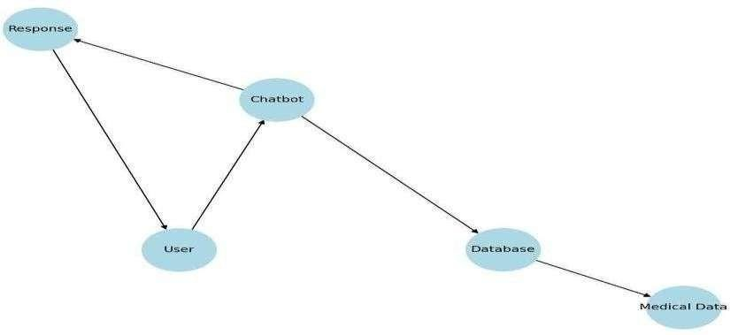

Figure 6.2.1: ER Diagram Users – Stores details of users interacting with the chatbot.
Queries – Stores all health-related queries from users.

Responses – Contains chatbot-generated responses.

Database – Stores past interactions for reference and improvement.

Patterns – Helps the chatbot recognize recurring health concerns.

DATA FLOW DIAGRAM
The Data Flow Diagram (DFD) represents the flow of information within the Healthcare Chatbot system. It visually depicts how data moves between users, processes, and storage components. The DFD is structured into two levels:

- Level 0: High-level overview of the system.

- Level 1: Detailed flow of data between different entities.

- Level 0 DFD: The Level 0 DFD shows the Healthcare Chatbot system as a single entity interacting with:

User (Patient): Sends health queries.
Healthcare Chatbot (Healthcare Bot): Processes queries and generates responses.
Database: Stores past interactions for reference.

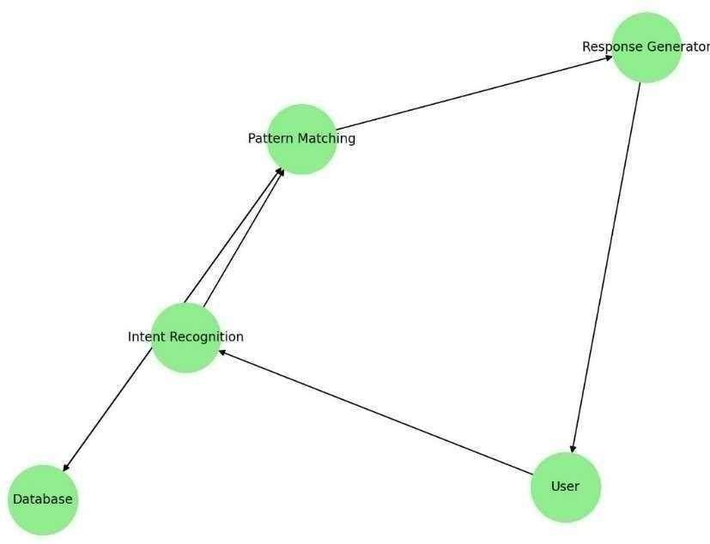

Figure 6.3.1: Level 0 Data Flow Diagram

- Level 1 DFD

The Level 1 DFD breaks down the system into multiple processes, showing how data is transferred between different components:

Users input health-related queries.

Data is processed by the intent classification model.

The chatbot searches for a matching response in the database.

If no response is found, the chatbot stores the new query for future improvements. The chatbot generates and sends responses to the user.
System updates the response database for enhanced accuracy.

6.4 CONCLUSION

The Healthcare Chatbot system follows a document-based structure using MongoDB, making it scalable, flexible, and efficient. Each collection represents a key entity, while relationships are managed using references (ObjectIds) or embedded documents. This structure ensures fast querying, minimal redundancy, and high performance, making the chatbot an efficient tool for providing health-related.

CHAPTER 7 OUTPUT SCREENS
- 1 Output Screen
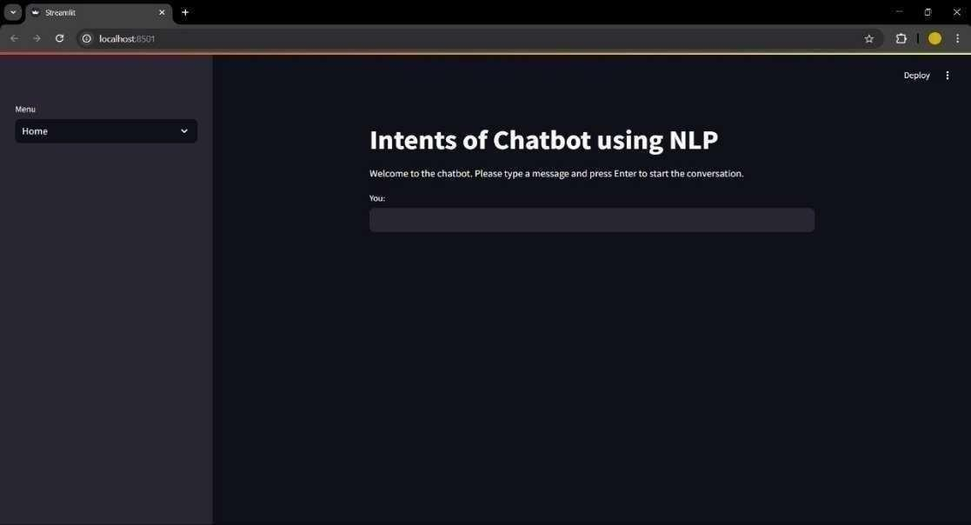

Figure 7.1.1: Home page

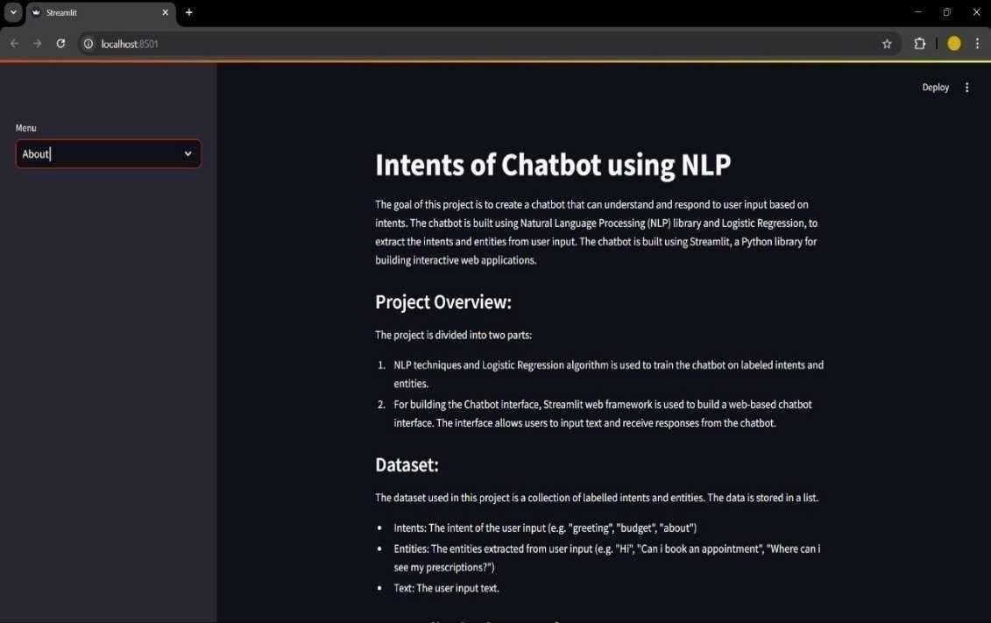

Figure 7.1.2: About us

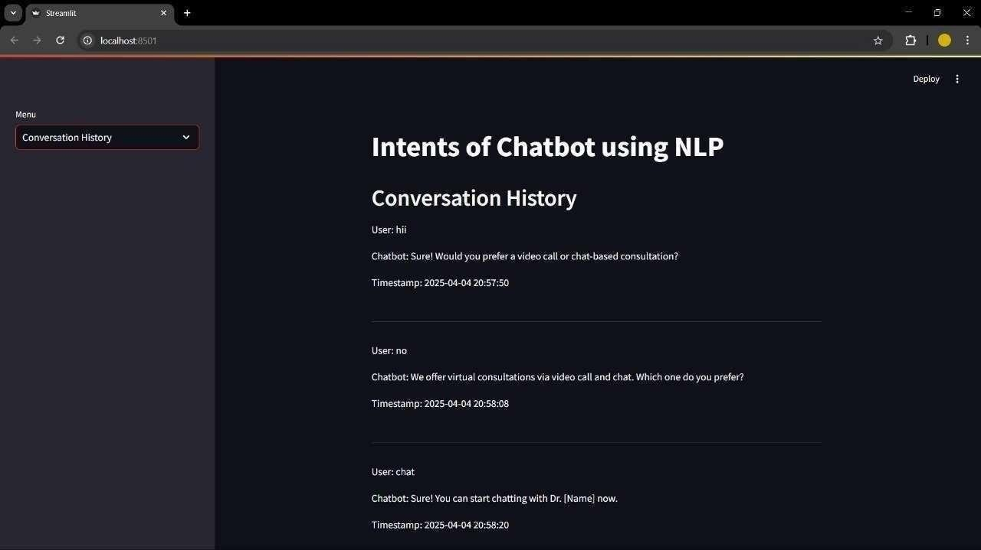

Figure 7.1.3: Conversation with user

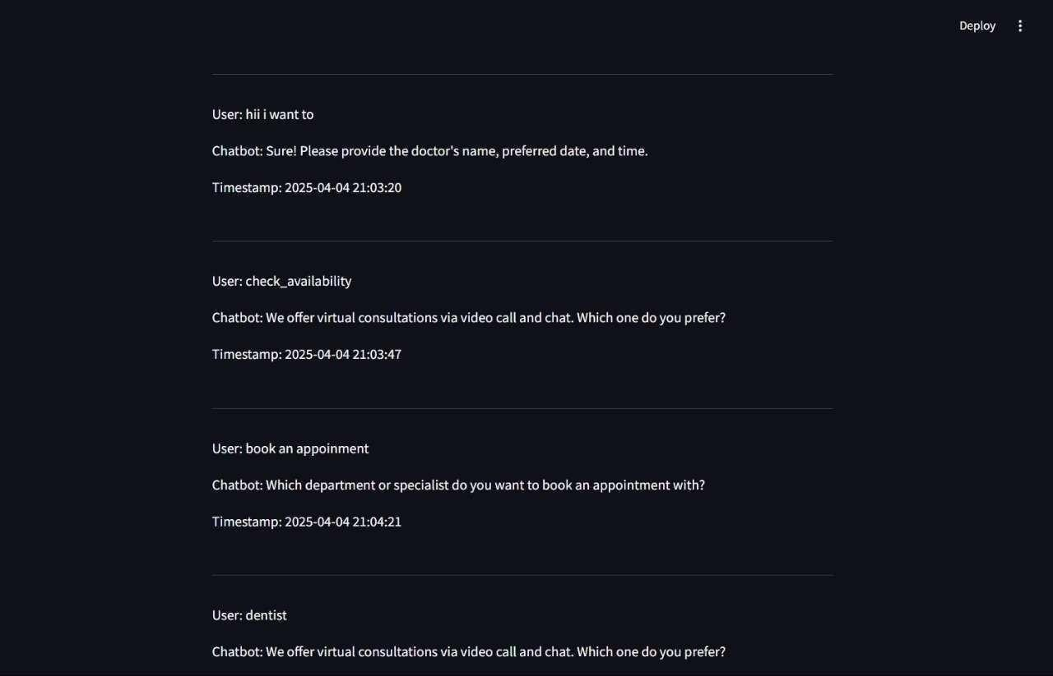

Figure 7.1.4: Output Screen

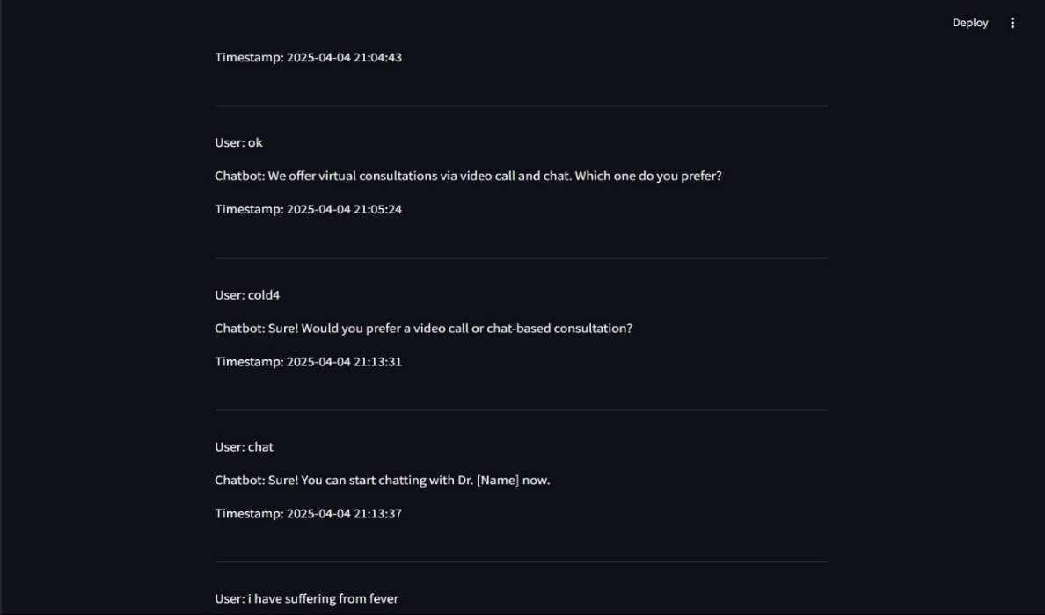

Figure7.1.5: Output no.2

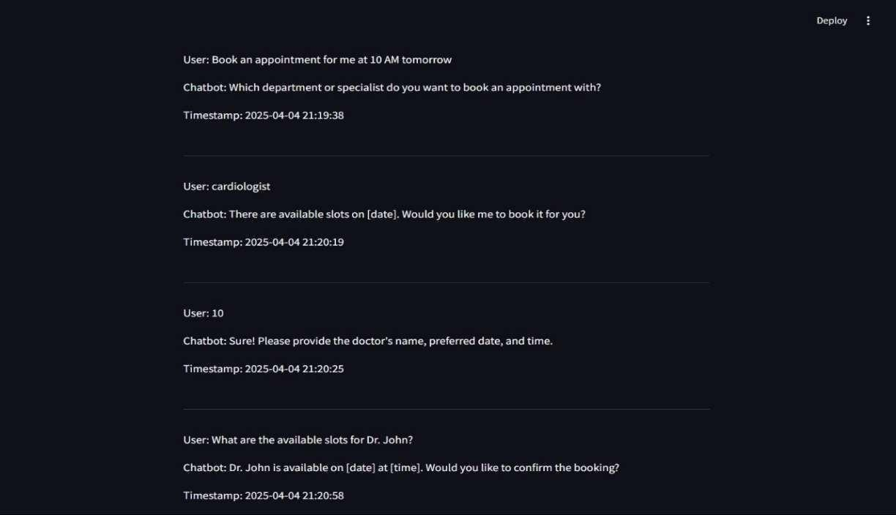
Figure 7.1.6: Output no.3

CHAPTER 8 DEPLOYMENT

8.1 OVERVIEW
Deployment is the final stage of software development, where the Healthcare Chatbot system is made accessible to end users over the internet. To ensure efficient performance and seamless interactions, the project is deployed using cloud-based services that ensure scalability, high availability, and secure data access.
In this project, the frontend is built using Streamlit, a Python-based web framework ideal for building fast and interactive UI interfaces for ML models. The backend includes a Flask-based API that manages NLP tasks and integrates a machine learning model trained using Scikit-learn. Both frontend and backend are deployed using Render, a cloud platform that supports Python-based apps. The database is managed through MongoDB Atlas, offering reliable, cloud-based NoSQL storage for user queries and chatbot responses.
The system’s ML model utilizes TF-IDF vectorization and Logistic Regression for classifying user intent and generating suitable responses. This chapter outlines the deployment process, cloud configuration, and CI/CD strategy implemented for a fully functional chatbot platform.

DEPLOYMENT ARCHITECTURE
Frontend (UI Layer): Streamlit

Backend: Python (Flask Framework)

Database: MongoDB Atlas (Cloud-based NoSQL)

Machine Learning Libraries: Scikit-learn

ML Components: TF-IDF Vectorizer + Logistic Regression

Deployment Tools: GitHub, Render, MongoDB Atlas

DEPLOYMENT OF FRONTEND

The user interface of the chatbot is developed using Streamlit, a Python framework that simplifies the creation of interactive dashboards and web apps. Render is used to deploy the Streamlit app as a public web service.

Steps to Deploy Streamlit on Render:

Push the Streamlit app code to a GitHub repository. Log into Render.com and click “New Web Service.” Connect the GitHub repo and choose Python as the environment. In the build settings, specify streamlit run app.py as the start command.
Add required environment variables such as backend API URL and MongoDB keys. Click Deploy and wait for the build to complete.
Once deployed, Render provides a live URL where users can access the chatbot’s Streamlit interface.

DEPLOYMENT OF BACKEND

The backend consists of a Flask application that handles intent detection, connects with the ML model, and processes user queries. This component is also deployed using Render.

Steps to Deploy Flask Backend on Render:

Push the backend code to GitHub.

On Render, click “New Web Service” and select the repository.

Choose Flask as the framework, set the start command to python app.py.

Add necessary environment variables (MongoDB URI, model path). Enable Auto Deploy for CI/CD support.
Wait for the build and deployment to complete.

After deployment, a public API URL is generated which is used by the Streamlit frontend.

DATABASE SETUP

The system uses MongoDB Atlas to store queries, logs, and response data. Atlas provides a cloud- based NoSQL solution that is easy to scale and secure.

Steps to Set Up MongoDB Atlas:

Register on MongoDB Atlas.

Create a new project and cluster (free tier is sufficient). Create a database and collections (e.g., users, queries). Whitelist IP addresses and generate a connection string.
Add the URI as an environment variable in the backend Render dashboard.

MODEL DEPLOYMENT (NLP + ML)

The core of the chatbot’s intelligence lies in its intent classification model built with Scikit-learn.
Vectorizer: TF-IDF Vectorizer to convert text to numerical form.

Classifier: Logistic Regression trained on labeled intents.

The model and vectorizer are serialized using joblib and loaded into the backend at runtime. The model predicts the user’s intent and selects an appropriate response.

These components are integrated into the Flask backend, and results are served to the frontend via API.

CONTINUOUS DEPLOYMENT

Render supports automatic deployments triggered by code changes in GitHub.

Steps to Enable Continuous Deployment:
Link both Streamlit (frontend) and Flask (backend) GitHub repos to Render. Enable “Auto Deploy” when setting up each web service.
Push changes to GitHub → Build and deploy are triggered automatically. Monitor build status and live logs via Render dashboard.

CONCLUSION

The Healthcare Chatbot is successfully deployed using Streamlit for the frontend and Flask for the backend, both hosted on Render. The system uses MongoDB Atlas for cloud-based storage and integrates a Scikit- learn ML model with TF-IDF and Logistic Regression. With continuous deployment enabled via GitHub and Render, the system remains scalable, maintainable, and ready for real-world.

REFERENCES

JOURNAL / RESEARCH PAPERS

- S. K. Rajendran et al., “Medical Chatbot for Simulated Diagnosis: A Deep Learning Approach,” Journal of Biomedical Informatics, 2022.
- T. Nguyen and R. S. Holmes, “Risks and Limitations of Medical Chatbots in Primary Care,” BMJ Health & Care Informatics, 2020.
- S. Zuehlke, “Language Barriers in AI Chatbots: NLP Challenges and Solutions,” ACM Transactions on AI and NLP, 2021.
- S. Patel and A. Mehta, “Privacy and Security in AI Healthcare Applications,” International Journal of e-Health and Medical Communications, 2020.
- M. L. Williams, “Scalability of AI Chatbots in Healthcare,” Healthcare Informatics Research, 2021.
- N. A. Rahman et al., “Integration of Chatbots with EHR Systems: Opportunities and Challenges,” Journal of Medical Systems, 2022.
- K. S. Chouhan, “Voice-Enabled Healthcare Assistants: NLP and Speech Recognition,” IEEE Access, 2021.
- D. S. Kumar et al., “Predictive Analytics for AI-based Triage in Emergency Care,” Computer Methods and Programs in Biomedicine, 2021.

PROJECT SUMMARY
About Project

Title of the project | Healthcare chatbot using ML in python
Semester | 8th
Members | 4
Team Leader | Utsav Raj
Describe role of every member in the project | Satya Ranjan Majhi: Responsible for Data Cleaning and Preprocessing.  Vishakha Sharma: Implemented NLP Modules and Symptom Analysis.  Utsav Raj: Worked on Backend Integration and Model Development.  Zeeshan Alam: Handled Frontend Design using Stream lit.
What is the motivation for selecting this project? | The primary motivation behind this project is to build an intelligent and accessible healthcare solution that helps users  identify symptoms and get preliminary medical guidance without needing to visit clinics physically.
Project Type (Desktop Application,  Web Application, Mobile App, Web) | Web Application

Tools & Technologies

Programming language used | Python 3.10
IDE used (with version) | Visual Studio Code v1.98
Front End Technologies (With version, wherever Applicable) | Streamlit v1.30
Back End Technologies (With version, wherever applicable) | Python Libraries: Scikit-learn, Pandas, NumPy

Software/Hardware Design & Coding

Is prototype of the  software/hardware developed? | Yes
SDLC model followed (Waterfall, Agile, Spiral etc.) | Agile
Why above SDLC model is followed? | Agile supports iterative development with better flexibility and feedback.
Justify that the SDLC model mentioned above is followed in the project. | The team conducted multiple sprints to make required improvements.
Software Design approach followed  (Functional or Object Oriented) | Object Oriented
Name the diagrams developed  (According to the Design approach followed) | Use Case Diagram, Data Flow Diagram, ER Diagram
In case Object Oriented approach is followed, which of the OOPS principles are  covered in design? | Encapsulation (data protection), Inheritance (NLP modules reuse), Polymorphism (responses handling), Abstraction (symptom logic)
No. of Tiers (Example 3-tier) | 3-Tier
Total no. of Frontend pages | 10
Front end validations applied (Yes / No) | Yes
Session management done  (in case of web applications) | Yes
Is application browser compatible  (In case of web  applications) | Yes
Exception handling done (Yes / No) | Yes
Commenting done in code  (Yes / No) | Yes
Naming convention followed  (Yes / No) | Yes

What difficulties faced during deployment of project? | During development, we faced several challenges such as integrating real-time symptom prediction, training a robust NLP model to accurately detect user intents, handling varied datasets for different disease categories, and ensuring the Streamlit UI was interactive and responsive. Overcoming these required model tuning, efficient preprocessing, and optimization of response generation.
Total no. of Use-case | 7
Give titles of Use-cases | User Login & Signup Symptom Submission Disease Prediction Health Tips Generation  Emergency Redirect Feature  Chatbot Interaction Logging Admin Dashboard for Monitoring
Project Requirements

MVC architecture followed (Yes / No) | Yes
If yes, write the name of  MVC architecture followed (MVC-1, MVC-2) | MVC-2
Design Pattern used (Yes / No) | Yes
If yes, write the name of Design Pattern used | MVC Pattern
Interface type (CLI / GUI) | GUI
No. of Actors | 3
Name of Actors | User, Chatbot, Admin
Total no. of Functional Requirements | 9
List few important non- Functional Requirements | Accuracy, Usability, Scalability, Availability

Testing

Which testing is performed?
(Manual or Automation)
Manual

  Is Beta testing done for this project? |   No

Write project narrative covering above mentioned points

The "Health Care Chatbot using Machine Learning" project is a smart virtual assistant system designed to provide healthcare advice based on symptoms described by the user. This chatbot system uses Natural Language Processing (NLP) to understand user queries and maps them to appropriate medical suggestions using machine learning models.
The backend employs Python along with Scikit-learn to create a Logistic Regression model. The model is trained using TF-IDF vectorization and a dataset of symptoms and illnesses. Frontend interaction is handled using Streamlit, providing an intuitive interface for users to chat with the system. Additionally, the system is capable of giving health tips and redirecting users to emergency services if required.
Our team is organized as follows:
- Utsav raj and Vishakha worked on model training and backend logic.
- Zeeshan focused on the UI/UX of the chatbot.
- Satya was responsible for preparing and cleaning the dataset.
The development followed the Agile SDLC model with multiple iterations and feedback sessions. The application is built with a clear MVC2 architecture, ensuring better code separation and maintainability. The system involves three main actors:
- User: Enters symptoms and interacts with the chatbot.
- Chatbot: Responds with predictions and health advice.
- Admin: Monitors system performance and manages the dataset.
The chatbot serves as a digital health consultant that can aid users by giving instant insights, promoting early detection of illnesses, and improving awareness. This project highlights the potential of AI in revolutionizing primary healthcare access.

Satya Ranjan Majhi 0187CS211149
Utsav Raj 0187CS211177
Vishakha Sharma 0187CS211182
Zeeshan Alam 0187CS211149

Guide Signature
(Prof. Mayank kurchaniya)

APPENDIX-1 GLOSSARY OF TERMS A
Admin A user with full access to manage chatbot data, models, and system configurations.

API (Application Programming Interface)
A set of protocols that enables communication between frontend and backend components.

Authentication Verifying user identity via login credentials to protect sensitive
health-related data

C
Chat Bot An intelligent conversational agent that interacts with users to analyze symptoms and provide medical advice.
Corpus A structured dataset of medical conversations used to train the NLP model for intent recognition.
CRUD Operations Create, Read, Update, and Delete functions used in data management across the system.

D

Data Preprocessing

The process of cleaning and preparing text data using NLP techniques for model training.

Dataset A collection of symptom-disease pairs used to train and evaluate machine learning models
Deep Learning A subfield of ML used for intent recognition and symptom analysis through LSTM and Transformers.

F
Frontend The user interface built with Streamlit, enabling interaction between users and the chatbot.

I

Intent Recognition

The ML-based method of identifying user intention from input text using NLP techniques.

L
LSTM(Long Short-Term Memory)

M
A type of neural network used to process sequential data like user chat inputs

Machine Learning The core technology behind the chatbot, enabling learning from health data to make predictions.
Middleware Functional components managing communication between user
interface and ML model.
Model Training The process of teaching the machine learning model to understand
intents and symptoms

N

Named Entity Recognition (NER)

NLP technique used to identify medical entities like symptoms and conditions in user queries.

Natural Language Processing (NLP)

P
A branch of AI that helps the chatbot understand and process human language.

Prediction The chatbot’s output, generated by the ML model, indicating possible diseases based on user symptoms.
A deep learning framework used to build and train the chatbot's intent
PyTorch and diagnosis models.

Python The programming language used for backend development, model training, and NLP integration.

S
Scikit-learn A Python library used for implementing traditional ML models and evaluation metrics.

Testing Manual verification and debugging of chatbot functionality and ML outputs.
Tokenizer An NLP tool used to split text into individual components like words or phrases.
Transformer A deep learning model used for advanced NLP tasks like intent
recognition and text generation.

U
UI/UX The design and usability features of the chatbot ensuring smooth and accessible interaction.

VVisualization

W
.
Graphical representation of data and model insights using Matplotlib and Seaborn.

Webhooks Automated communication triggers between frontend and backend for real-time chat response.

